**National University of Modern Languages,**

**Regional Campus, Hyderabad**

**Department of Computer Science**



**Name: Durr e shehwar**

**Batch: BSCS III**

**Practical no:2**

**Submitted to**

**Sir Rafay**

**Date:14-03-2023**

1. Verify following Rules of Boolean Algebra by designing them using Circuit Makers.
   1. Identity Law
   2. Idempotent Law
   3. Complement
   4. Involution Law
   5. Commutative Law
   6. Associative Law
   7. Distributive Law

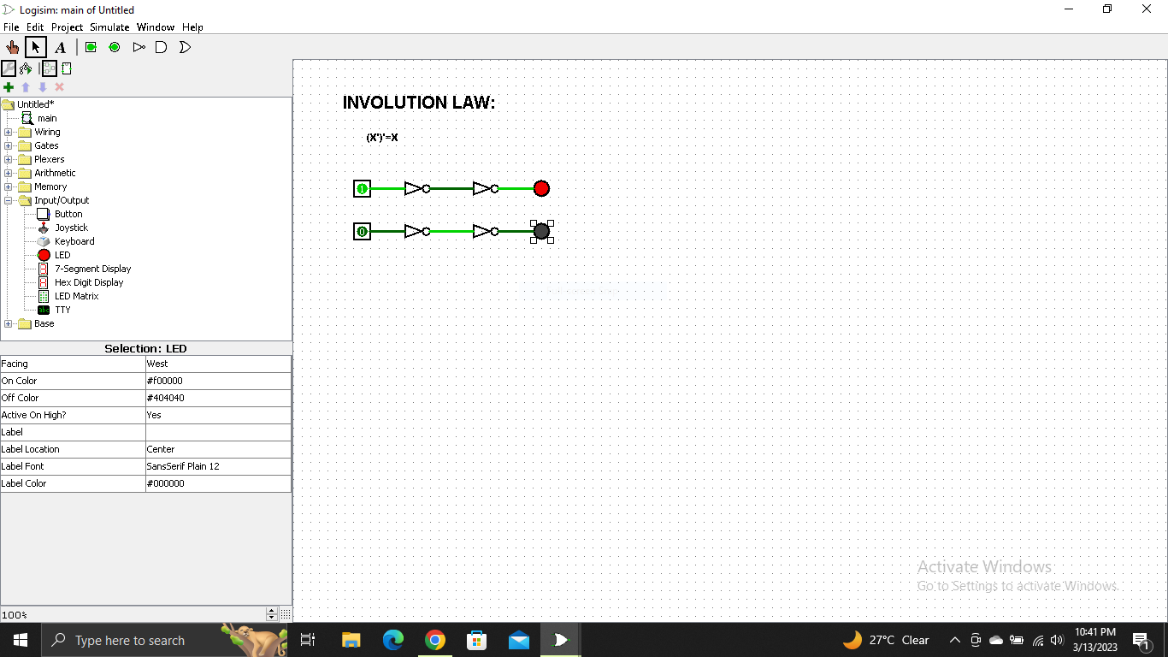

1. Simplify the expressions.

* F=(A+(BC)’)’
* F=(AB+CD)’

1. **F = (A+(BC)’)’**

**= A’ + [(BC)’]’ (X’)’=X**

**= A’ + BC**

1. **F = (AB + CD)’**

**= (AB)’ . (CD)’**

1. Use DE Morgan’s Theorem to prove that this NAND gate circuit performs the exact same function:

* **First circuit:**

Input = A , B

Output = (A.B)**’**

* **Second circuit:**

Input = C , D

Output = (C.D)**’**

* **Third circuit:**

Input = (A.B)**’** , (C.D)**’**

Output = [ (A.B)’ . (C.D)’ ]’

= ( (A.B)’ )’ + ( (C.D)’ )’

= A.B + C.D

1. Apply the principles of DE Morgan’s theorems to the simplification of a gate circuit:

2

5

4

3

1

* **First circuit:**

Input = B , C

Output = B+C

* **Second circuit:**

Input = A , (B+C)

Output = (A.(B+C) )’

* **Third circuit:**

Input = B

Output = B’

* **Forth circuit:**

Input = B’ , A

Output = (B’.A)’

* **Fifth circuit:**

Input = (A.(B+C))’ , (B’.A)’

Output = [ (A.(B+C))’ + (B’.A)’ ]’ (X+Y)’=X’.Y’

= [ (A.(B+C))’]’ . [ (B’.A)’ ]’ (A’)’=A

= A.(B+C) . B’.A A.(B+C) = AB + AC

= AB + AC . ( AB’)

= AABB’ + AAB’C AA=A , BB’=0

= A(0) + AB’C

= AB’C